VERILOG TRAFFIC LIGHTS REPORT

1. INTRODUCTION
In this project, we designed and implemented a traffic light controller using Verilog hardware description language.
The goal of the project was to understand basic digital design concepts such as finite state machines, counters,
and simulation using a testbench.

The traffic light system controls four directions: North, East, South, and West. Each direction gets a green signal
for a certain time, followed by a short all-red state before switching to the next direction. The system also includes
a night mode feature where all lights blink to simulate low-traffic conditions.

2. SYSTEM DESIGN
The system is based on a Finite State Machine. Each state represents a specific condition of the traffic lights.

States:
S0 – North Green
S1 – All Red
S2 – East Green
S3 – All Red
S4 – South Green
S5 – All Red
S6 – West Green
S7 – All Red

The FSM transitions from one state to the next based on a clock signal and a counter. The counter determines how long
each state lasts.

Timing:
- Green state duration: 3 clock cycles
- All-red state duration: 1 clock cycle

This ensures safe switching between directions.

3. VERILOG IMPLEMENTATION
The design was implemented in Verilog using three main components:

1. State Register:
Stores the current state and updates on each clock edge.

2. Counter:
Controls how long each state lasts by counting down clock cycles.

3. Output Logic:
Determines which traffic light is ON based on the current state.

Signal Encoding:
- 3'b001 = Green
- 3'b100 = Red

Example:
If the system is in state S0, the North direction is green while all others are red.

4. TESTBENCH AND SIMULATION
A testbench was created to simulate the design and verify its behaviour.

The testbench performs the following:
- Generates a clock signal
- Applies reset at the beginning
- Runs the system in normal mode
- Activates night mode after some time
- Returns to normal mode

Simulation was done using Icarus Verilog, and waveforms were viewed using GTKWave.

5. WAVEFORM ANALYSIS
The waveform shows how signals change over time.

Important signals:
- clk: The clock signal driving the system
- debug: Shows the current FSM state
- north, east, south, west: Output signals for traffic lights

Results:
- The debug signal cycles through values 0 to 7, representing FSM states
- Each green state lasts longer than the red state
- Outputs change according to the current state
- During night mode, signals toggle repeatedly imitating blinking.

This confirms that the FSM and timing logic are working correctly.

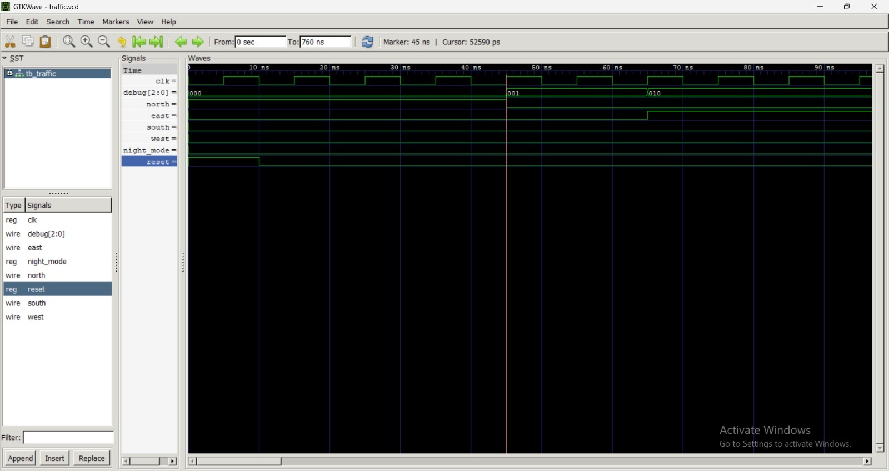

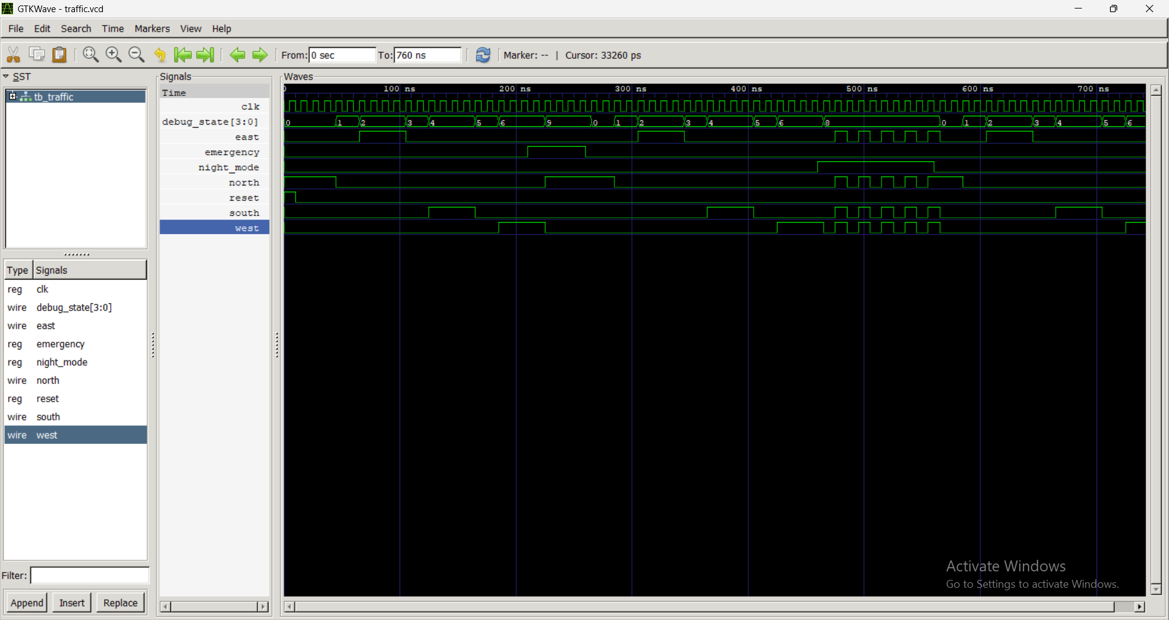

6. NIGHT MODE
An additional feature called night mode was implemented.

When night_mode = 1:
- The system stops normal operation
- All traffic lights blink simultaneously

This simulates a real-world low-traffic scenario, although in real systems yellow blinking is typically used.

